Ex. 2 A2 My city
Name: ____________________________ Surname: ____________________________ N^{ber}: ____ Grade/Class: _____
Assessment: _____________________________ | Date: ___________________________________________________
 | Teacher’s signature:  ___________________________ | Parent’s signature:  ___________________________

Our Playground
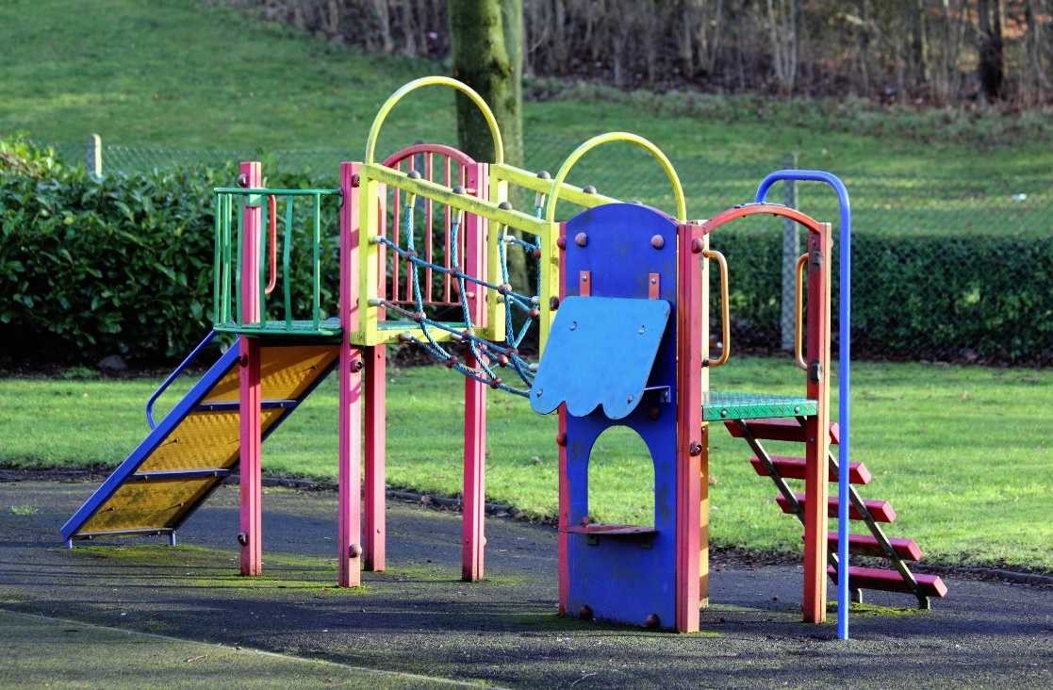

Listen and match the words with the right color

- Red a. slides
- Yellow b. swings
- Green c. baskets
- Blue d. grass

Key : 1 –b 2-a 3-d 4-c

Transcript:
There is a lovely, huge playground in my neibourhood. I go there almost every day with my sister.
We meet our friends and we play lots of games. You can walk for hours on the green grass. There are wonderful yellow slides for little children and red swings there.
The playground has blue plastic baskets everywhere to put the litter in.

