Exercise 3 A2 my city
Name: ____________________________ Surname: ____________________________ N^{ber}: ____ Grade/Class: _____
Assessment: _____________________________ | Date: ___________________________________________________
 | Teacher’s signature:  ___________________________ | Parent’s signature:  ___________________________

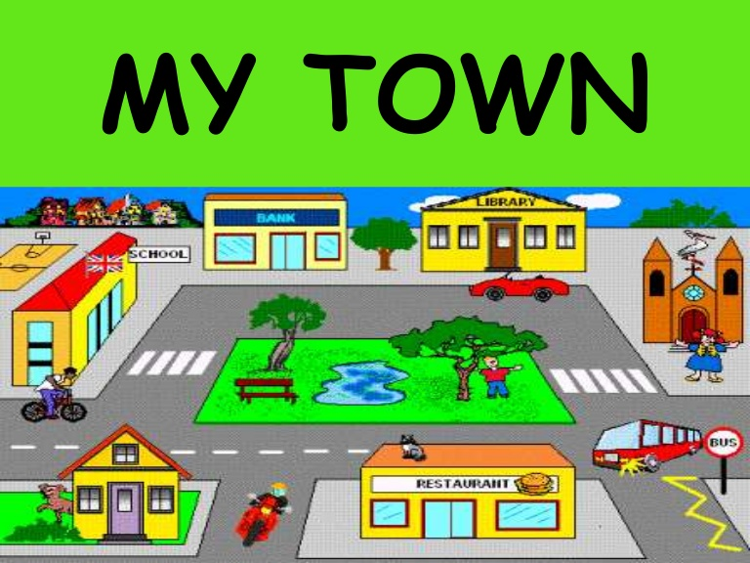

Listen and put √ or X next to the following sentences.
- In my town , there are 2 libraries ------------

- There is a park ……………..
- There are 4 restaurants ……………..

- There are 3 schools ……………..
- There are 3 banks ……………..
- There is a church -------------

- There are 5 shops -------------

Key: 1. X 2. V 3. X 4. X 5. V 6. V 7. X

Transcript:
My town is wonderful and I like it very much. There are so many buildings and so many things you can do in my town.
There is a lovely park where I play with my friends every day.
My town has a big church and one old library where we borrow books. There is also our school which is the only one in our town.
There are 10 shops and 3 banks in my town. Many people go to eat at restaurants. Actually, my town has 5 restaurants.

