Ex. 4 A2 My city
Name: ____________________________ Surname: ____________________________ N^{ber}: ____ Grade/Class: _____
Assessment: _____________________________ | Date: ___________________________________________________
 | Teacher’s signature:  ___________________________ | Parent’s signature:  ___________________________

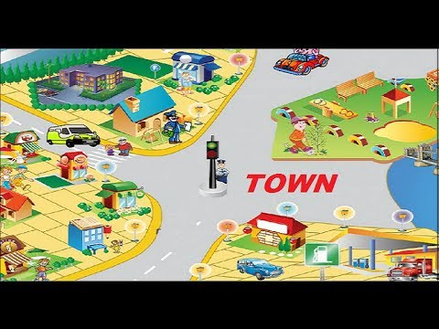
Listen and write YES or NO next to the following city words.

- Car park ----------------
- Post Office ---------------
- Petrol Station ---------------
- Bus Station ----------------
- Hospital -----------------

Key 1 yes 2 no 3 no 4.yes 5.yes

Transcript :

In my neighborhood, there is one bus station and many people wait for the bus every morning.
Also, there is a very big car park where my parents leave their cars when they come back from work.
There is a big hospital too just a few meters away from the main square.
That’s all about my neighborhood!

