Ex. 5 A2 My city
Name: ____________________________ Surname: ____________________________ N^{ber}: ____ Grade/Class: _____
Assessment: _____________________________ | Date: ___________________________________________________
 | Teacher’s signature:  ___________________________ | Parent’s signature:  ___________________________
Listen and write next to the photo what you can find in a big city:

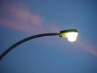 L___________________
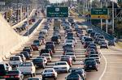 C____________________
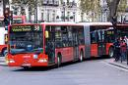 B___________________
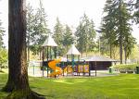 P______________________
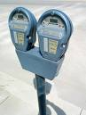 P__________________________

Transcript:

There are so many things you can find in a big city. First of all, the city is full of cars and buses. There are lights in all streets.
There is usually a park where people go to relax in the afternoon. Also, there are a lot of parking areas in streets or at squares.

