TOPIC: My city | SUBTOPICS: Vocabulary | LEVEL: A2
Name: ____________________________ Surname: ____________________________ N^{ber}: ____ Grade/Class: _____

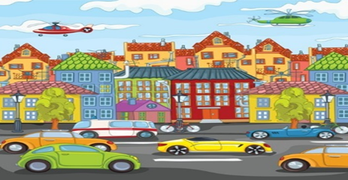

Match the following words with the places in a town/city.

cars/ students/ nurses/ airplanes/ trains/ trees /aspirins/books/ athletes/ milk

1. Hospital ------------------

2. School ------------------

3. Airport ------------------

4. Park …………….......

5. Pharmacy ----------------

6. Road ------------------

7. Train station -------------------

8. Library _____________

9. Stadium _____________

10. Dairy shop _____________

KEY
1 NURSES 2. SCHOOL 3. AIRPLANES 4. TREES 5. ASPIRINS 6.CARS 7. TRAINS 8. BOOKS 9. ATHLETES 10. MILK

