Exercise 1 A2 My city
Name: ____________________________ Surname: ____________________________ N^{ber}: ____ Grade/Class: _____
Assessment: _____________________________ | Date: ___________________________________________________
 | Teacher’s signature:  ___________________________ | Parent’s signature:  ___________________________

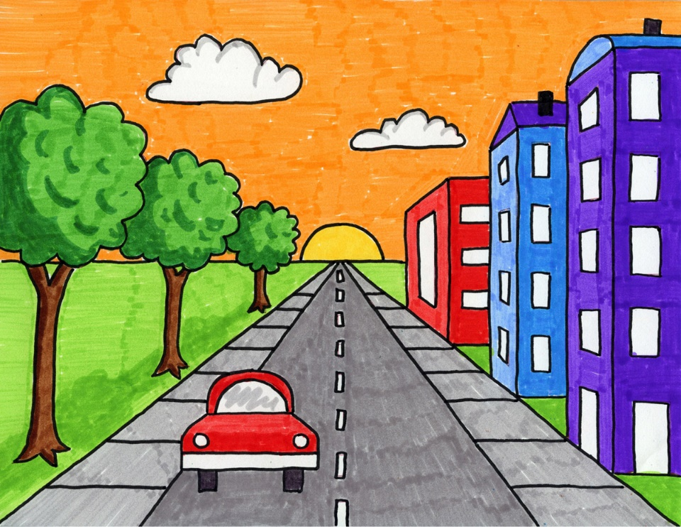
What you can see in this picture? Write 5 sentences using there is/ there are
E.g. there is a red building in the picture
1. -------------------------------------------------------------------------
2. -------------------------------------------------------------------------
3. -------------------------------------------------------------------------
4. -------------------------------------------------------------------------
5. -------------------------------------------------------------------------

