Ex2 A2 My city
Name: ____________________________ Surname: ____________________________ N^{ber}: ____ Grade/Class: _____
Assessment: _____________________________ | Date: ___________________________________________________
 | Teacher’s signature:  ___________________________ | Parent’s signature:  ___________________________

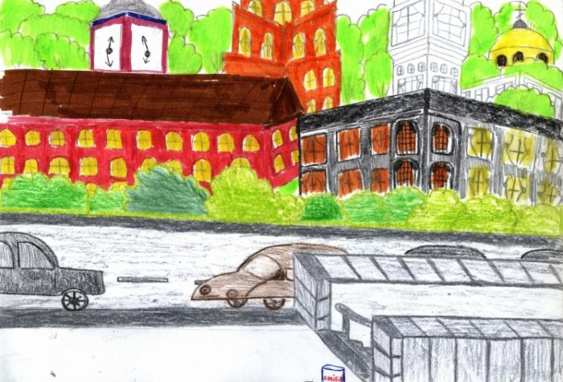

This is a painting of my city.
There are many cars but there isn’t a park. There is a big church but there isn’t a hospital.
Write 5 sentences about what there is (isn’t) / there are (aren’t) in your town /city.
- -------------------------------------------------------------------------------------------------
- -------------------------------------------------------------------------------------------------
- -------------------------------------------------------------------------------------------------
- -------------------------------------------------------------------------------------------------
- --------------------------------------------------------------------------------------------------

