Ex. 4 A2 my city
Name: ____________________________ Surname: ____________________________ N^{ber}: ____ Grade/Class: _____
Assessment: _____________________________ | Date: ___________________________________________________
 | Teacher’s signature:  ___________________________ | Parent’s signature:  ___________________________

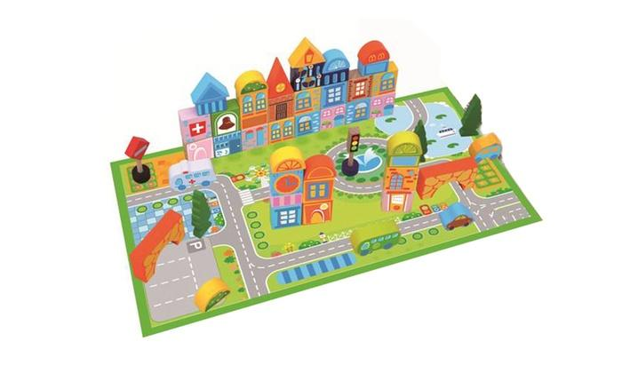
Match the places in a city with the following words.

Books/ films /playground/ cars/ café

- Park -----------------------------------
- Public Library -----------------------------------
- Cinema -----------------------------------
- Parking -----------------------------------
- Square -----------------------------------

Task Achievement - Two points for each correct answer given (10 Marks)
Excellent: 9-10 🙂👏
Very Good: 7-8 🙂
Satisfactory: 5-6 😐
Unsatisfactory: 3-4 ☹️
Poor: 0-2 ☹️

KEY

- PLAYGROUND 2 BOOKS 3. FILMS 4. CARS 5. CAFÉ

