Ex. 4 A2 My city
Name: ____________________________ Surname: ____________________________ N^{ber}: ____ Grade/Class: _____
Assessment: _____________________________ | Date: ___________________________________________________
 | Teacher’s signature:  ___________________________ | Parent’s signature:  ___________________________

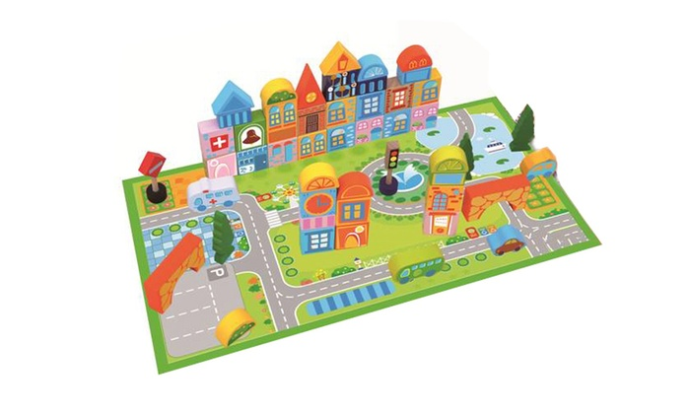
Match the places in a city with the following words.

Books/ films /playground/ cars/ café

- Park -----------------------------------
- Public Library -----------------------------------
- Cinema -----------------------------------
- Parking -----------------------------------
- Square -----------------------------------

