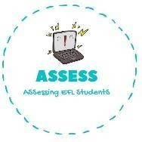
- Read the text and answer the questions.
Name: Surname: N^{ber}: Grade/Class:
Assessment: | Date:
 | Teacher’s signature: | Parent’s signature:

ENGLISH EXAM

Reading

Hello, my name is Tom. I am 8 years old and I have a brother. My brother is 4 years old. I wake up in the morning at 8 o’clock. I love having breakfast. My brother plays with his toys and I get dressed for school. At 9 o’clock I go to school with my friends. At school I learn English, Maths, History and P.E. At 2 o’clock I go home and have lunch with my family. We talk a lot. At 4 o’clock I do my homework and my father
helps me. I go shopping with my mum and I help her to make dinner. At 8 o’clock we watch TV at home.

At 9 o’clock I go to bed.

  - How old is Tom? Tom is old.

  - Tom makes his bed and

  - What time does Tom go to school? Tom goes to school at

  - What does Tom learn at school? Tom learns at school.

  - What does Tom do with his mum? Tom goes with his mum.

Assessing EFL Students

