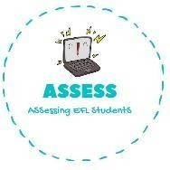
1. Read the text and write true or false.
Name: Surname: N^{ber}: Grade/Class:
Assessment: | Date:
 | Teacher’s signature: | Parent’s signature:

ENGLISH EXAM

Reading

I wake up at 8 o’clock, I have breakfast with my parents, and I go to school with my classmate Lucas.
I like studying History and English. I go back home and have lunch with my sister. My favourite meal is fish and chips.
In the afternoon I do my homework, my mother helps me usually. At 18 o’clock I can go to the playground with my friends.
Then, I must go to my house, and I have a shower. I have dinner with all my family. I brush my teeth everyday and I go to sleep at 21:00.

I wake up at 9 o’clock
I go to school alone
I like History and English
My favourite meal is eggs and chips
My mother helps me with my homework
I go to sleep at 22:00

Assessing EFL Students

