

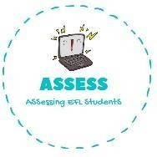1. Choose the correct option

|  |  |  |
| --- | --- | --- |
| **Name: Surname: Nber: Grade/Class:** | | |
| **Assessment:** | **Date:** | |
| **Teacher’s signature:** | **Parent’s signature:** |

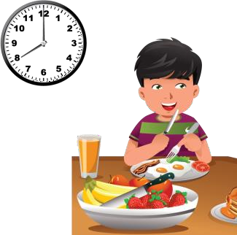

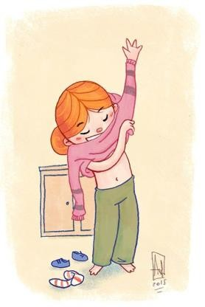

**ENGLISH EXAM**

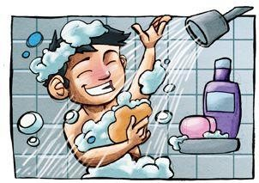Reading



|  |  |  |
| --- | --- | --- |
| Have breakfast | Go to school | Have lunch |
| Go to sleep | Brush my teeth | Go to the playground |
| Have lunch | Have a shower | Do homework |

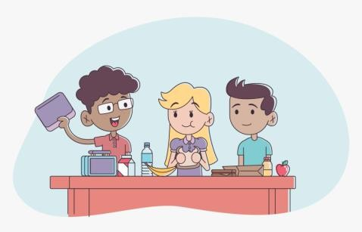

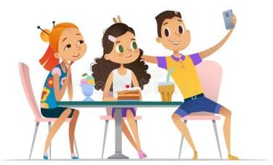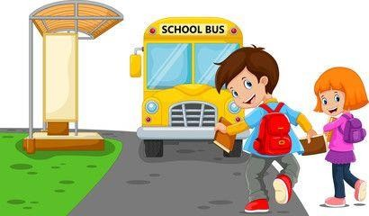

Assessing EFL Students

|  |  |  |
| --- | --- | --- |
| Have dinner | Go shopping | Go to school |
| Wake up | Meet friends | Have lunch |
| Get dressed | Do homework | Wake up |