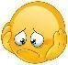

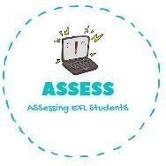
Read and match
Name: Surname: N^{ber}: Grade/Class:
Assessment: | Date:
 | Teacher’s signature: | Parent’s signature:

ENGLISH EXAM

Reading

You do it after waking up 1. Do homework

You do it after eating 2. Go to sleep

You do it to be clean 3. Brush my teeth

The teachers send it to you at school 4. Have breakfast

You do it at the end of the day 5. Have a shower

Put the number of the previous exercise in the correct picture and draw it.

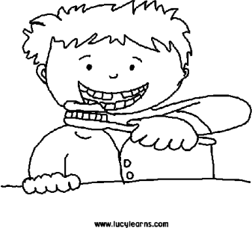
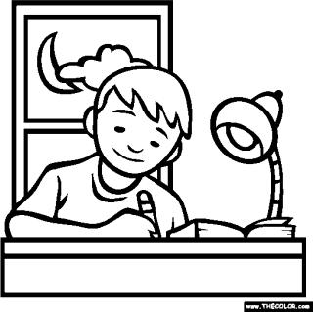
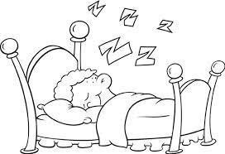
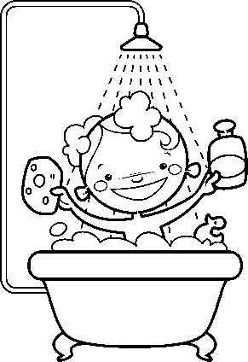
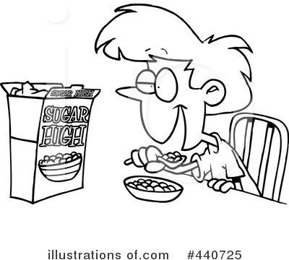

Assessing EFL Students

