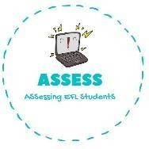
1. Match the sentences
Name: Surname: N^{ber}: Grade/Class:
Assessment: | Date:
 | Teacher’s signature: | Parent’s signature:

ENGLISH EXAM

Reading

- What time do you get up? a. I learn subjects like History

- What do you do in the afternoon? b. I play football in my free time

- What do you do in the school? c. I get up at 8 o’clock

- What do you do in your free time? d. I go to sleep

- What do you do after eating? e. I do my homework

- What do you do at night? f. I brush my teeth

Assessing EFL Students

