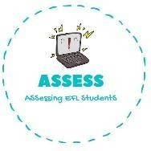
1. Order the words.
Name: Surname: N^{ber}: Grade/Class:
Assessment: | Date:
 | Teacher’s signature: | Parent’s signature:

VT ATCHW: LPYA LLBAFTOO: HSRBU YM IRAH:
HBRSU YM HHTEE: INEN LCCKOO’: RFEE IMTE: ENNGIVE: ORNGINM:

ENGLISH EXAM

Reading

Assessing EFL Students

