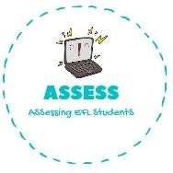
ENGLISH EXAM
Speaking

Name: Surname: N^{ber}: Grade/Class:
Assessment: | Date:
 | Teacher’s signature:  _ | Parent’s signature:

1. What are they doing?

He . | He . | She her .
They . | They . | She to .

Assessing EFL Students

