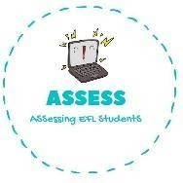
ENGLISH EXAM

Speaking

FALSE
Name: Surname: Nber: Grade/Class:
Assessment: | Date:
 | Teacher’s signature: | Parent’s signature:

FALSE FALSE FALSE FALSE FALSE FALSE
1. | Ask your partner and circle TRUE or FALSE.
1. | Do you get up at 8 o’clock? | TRUE
2. | Do you go to school by car? | TRUE
3. | Do you do your homework after school? | TRUE
4. | Do you watch TV in your free time? | TRUE
5. | Do you have dinner with your family? | TRUE
6. | Do you brush your teeth before going to sleep? | TRUE
7. | Do you go to sleep at 21 o’clock? | TRUE

Assessing EFL Students

