Name: Surname: N^{ber}: Grade/Class:
Assessment: | Date:
 | Teacher’s signature:  _ | Parent’s signature:
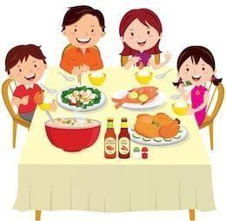
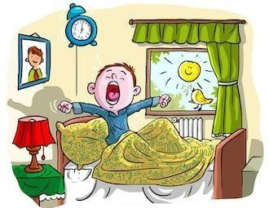
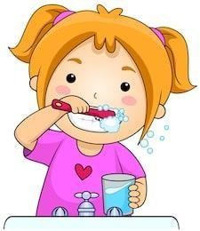
1. Ask your partner and write his answer.

-What do you do at 9 o’clock?  -At 9 o’clock I . | -What do you do at 10 o’clock?  -At 10 o’clock I . | What do you do at 11 o’clock?  At 11 o’clock I .
What do you do at 1 o’clock?  I with my friends.  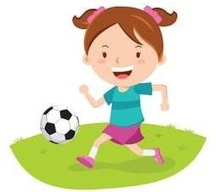 | What do you do at 3 o’clock?  I with my family. | What do you do at 4 o’clock?  I do .  