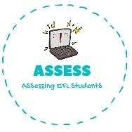
ENGLISH EXAM SPEAKING

Name: Surname: N^{ber}: Grade/Class:
Assessment: | Date:
 | Teacher’s signature:  _ | Parent’s signature:

1. Look at the pictures and present your routine to your colleagues
I ...... ...... at 9 o’ clock. I with my sister and my pet.

I ...... ........... I ....... ...... .......... I with my friend.

Assessing EFL Students

