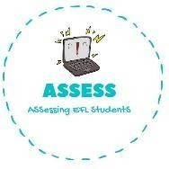
ENGLISH EXAM

Speaking

Name: Surname: N^{ber}: Grade/Class:
Assessment: | Date:
 | Teacher’s signature: | Parent’s signature:

1. Present your morning routine to your partners.

I wake up at
I have at o’clock

Every morning I have a ,

, 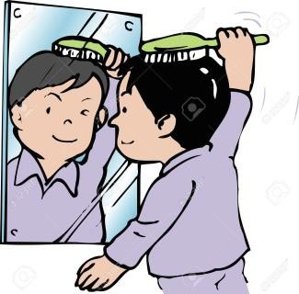,
Then I my teeth, I brush my and I go to .

Assessing EFL Students

