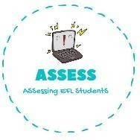
ENGLISH EXAM

Speaking

Name: Surname: N^{ber}: Grade/Class:
Assessment: | Date:
 | Teacher’s signature: | Parent’s signature:

1. Present your evening routine to your partners.

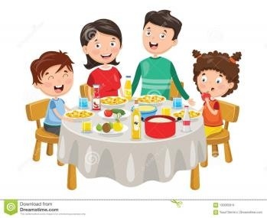
When I come back from I have with my ,
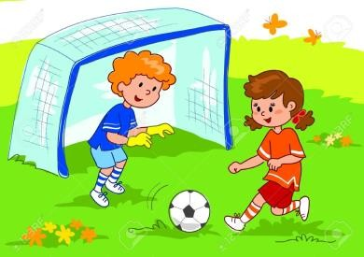
I do my , I go to the to play . I go back home, and I have a
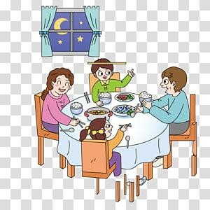
I watch . Then I have with my family and finally I go to .

Assessing EFL Students

