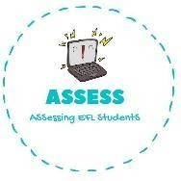
- Tell your partners what time it is.
Name: Surname: N^{ber}: Grade/Class:
Assessment: | Date:
 | Teacher’s signature: | Parent’s signature:

ENGLISH EXAM

Speaking

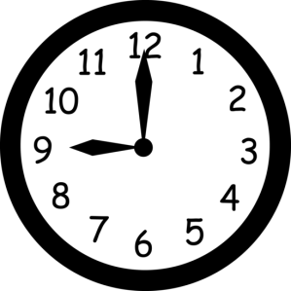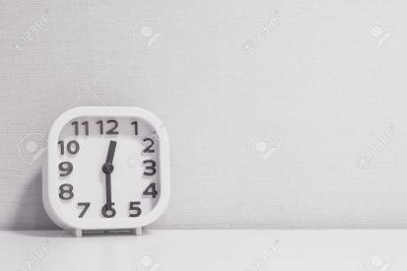
A) It is o’clock B) It is half past .

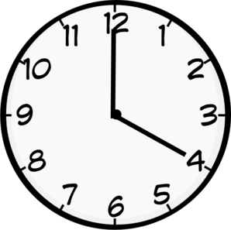
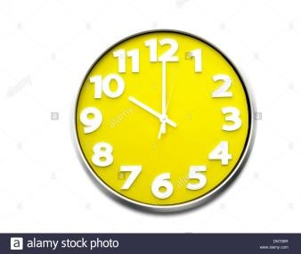
C) It is . D) It is .

- What are you doing at those hours?

- At I go to .
- At I have .
- At I do my .
- At I go to .

Assessing EFL Students

