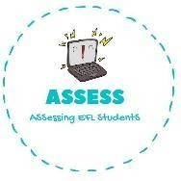
Ask your partner.
Name: Surname: N^{ber}: Grade/Class:
Assessment: | Date:
 | Teacher’s signature: | Parent’s signature:

- A: What time do you get up?
B: I wake up at .

- A: Who do you have breakfast with?
B: I have breakfast with .

- A: How do you go to school?
B: I go to school by .

- A: What do you do in your free time? B: In my free time I play .

Match the numbers with the pictures.
ENGLISH EXAM

Speaking

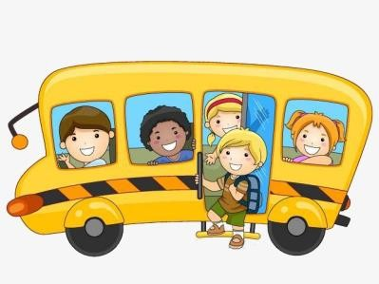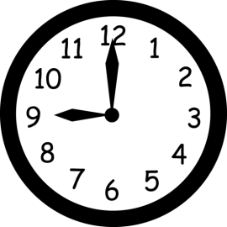

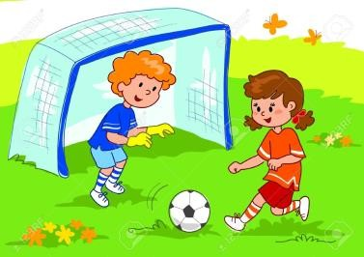
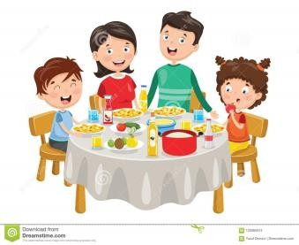Assessing EFL Students

