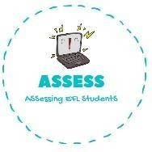
ENGLISH EXAM

Vocabulary

Name: Surname: N^{ber}: Grade/Class:
Assessment: | Date:
 | Teacher’s signature: | Parent’s signature:

1. Complete the words and match with the pictures
G_ t_ t_ _ p_ _ y _ _ _ _ _ _ M_ _ _ f _ _ _ _ _ _
D_ h_ _ _ w _ _ _

G_ s_ _ _ _ _ _ _
H_ _ _ _ d_ _ _ _ _

Assessing EFL Students

