

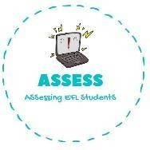1. Write the correct word and match.

|  |  |  |
| --- | --- | --- |
| **Name: Surname: Nber: Grade/Class:** | | |
| **Assessment:** | **Date:** | |
| **Teacher’s signature:** | **Parent’s signature:** |

**ENGLISH EXAM**

Vocabulary

|  |  |  |
| --- | --- | --- |
| **A _ _ _ _ _ _ _ _** | **N _ _ _ _** | **M _ _ _ _ _ _** |

**22: 00 8:00 16: 00**



|  |  |  |
| --- | --- | --- |
| **B _ _ _ _ _ _ _ _** | **D _ _ _ _ _** | **L _ _ _ _** |



Assessing EFL Students