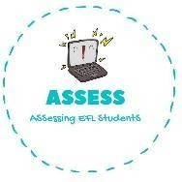
1. Order the words.
Name: Surname: N^{ber}: Grade/Class:
Assessment: | Date:
 | Teacher’s signature: | Parent’s signature:

Ewka pu ------>

Veah a wshero -------->

Shbru ym htteeh -------->

Og ot het ylgaoprund -------->

Eahv feraastbk ------>

Tge ssrdeed ------->

Eetm riendfs ------->

Og ot loochs ------->

Aevh nchlu --------->
ENGLISH EXAM

Vocabulary

Assessing EFL Students

