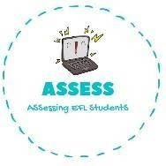
ENGLISH EXAM

Vocabulary

Name: Surname: N^{ber}: Grade/Class:
Assessment: | Date:
 | Teacher’s signature: | Parent’s signature:

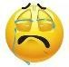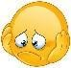1. Look at the clocks and write the correct hour.

Example: It is twelve o’clock / It is half past nine

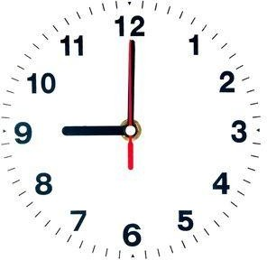
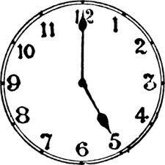
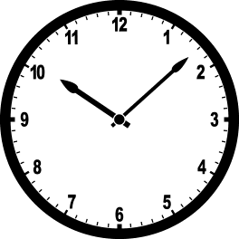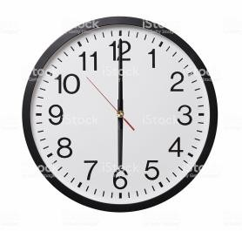

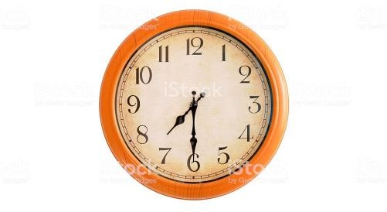
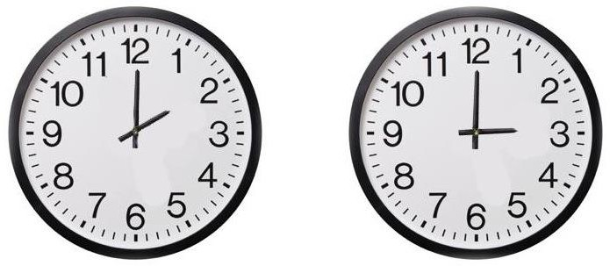

Assessing EFL Students

