

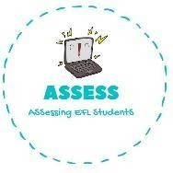1. Match the actions with the pictures.

|  |  |  |
| --- | --- | --- |
| **Name: Surname: Nber: Grade/Class:** | | |
| **Assessment:** | **Date:** | |
| **Teacher’s signature:** | **Parent’s signature:** |

ENGLISH EXAM

Vocabulary

|  |  |  |  |  |
| --- | --- | --- | --- | --- |
| Go to sleep | Watch TV | Play football | Brush my teeth | Have lunch |

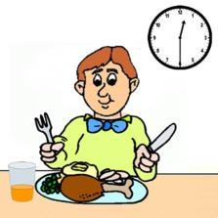

Assessing EFL Students