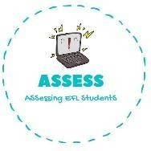
ENGLISH EXAM

Writing

Name: Surname: N^{ber}: Grade/Class:
Assessment: | Date:
 | Teacher’s signature: | Parent’s signature:

1. Complete the actions and match with the hour.

1. Have | School | 7 o’clock
2. Watch | Breakfast | 8 o’clock
3. Go to | Dinner | 9 o’clock
4. Wake | Sleep | 16 o’clock
5. Play | Up | 19 o’clock
6. Have | Football | 21 o’clock
7. Go to | TV | 22 o’clock

Assessing EFL Students

