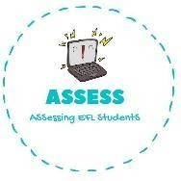
1. Complete the actions.
Name: Surname: N^{ber}: Grade/Class:
Assessment: | Date:
 | Teacher’s signature: | Parent’s signature:

ENGLISH EXAM

Writing

P_ _ _ F _ _ _ _ _ _ B _ _ _ _ m _ t _ _ _ _

B _ _ _ _ m _ h _ _ _ G _ t _ s _ _ _ _

W _ _ _ _ t _ D _ e x s _

Assessing EFL Students

