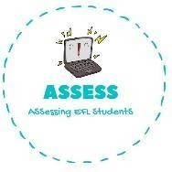
1. Write your daily routine and draw it
Name: Surname: N^{ber}: Grade/Class:
Assessment: | Date:
 | Teacher’s signature: | Parent’s signature:

ENGLISH EXAM

Writing

I wake up at , I have breakfast with and I

After school I have , I do my .In my free time I play
and I go .

At night I have , I also have a and I
before going to .

On Sundays I meet and I TV. Draw it.

Assessing EFL Students

