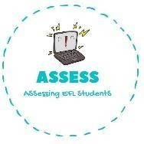
Match the times to the words.
Name: Surname: N^{ber}: Grade/Class:
Assessment: | Date:
 | Teacher’s signature: | Parent’s signature:

ENGLISH EXAM

Writing

9:00 Evening
12:00 Noon
16:00 Afternoon
19:00 Night

21:00 Morning

Look and write.

9:00 --> wake up

10:00 --> have breakfast

10:30 --> brush my teeth

11:00 --> go to playground and play with friends

14:00 --> have lunch

16:00 --> watch tv at home

19:00 --> go shopping

21:00 --> have dinner

22:00 --> go to bed

Assessing EFL Students

