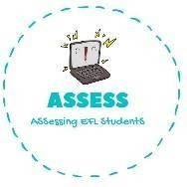
ENGLISH EXAM

Writing

Name: Surname: N^{ber}: Grade/Class:
Assessment: | Date:
 | Teacher’s signature: | Parent’s signature:

1. Look at the pictures and answer the questions.
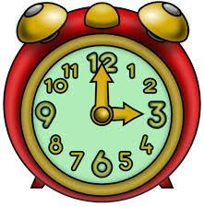
What time is it? What is he doing?
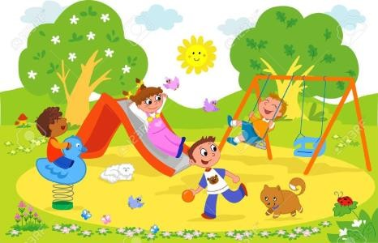

What are they doing? What is the child eating for breakfast?

What is the child doing?

Assessing EFL Students

