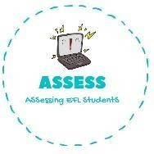
1. Answer the following questions.
Name: Surname: N^{ber}: Grade/Class:
Assessment: | Date:
 | Teacher’s signature: | Parent’s signature:

- What do you do in the morning?
ENGLISH EXAM

Writing

Draw it:

- What do you do in the afternoon?

Draw it:

- What do you do at night?

Draw it:

Assessing EFL Students

