

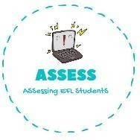**1. Write the following actions.**

|  |  |  |
| --- | --- | --- |
| **Name: Surname: Nber: Grade/Class:** | | |
| **Assessment:** | **Date:** | |
| **Teacher’s signature:** | **Parent’s signature:** |

Ej:  do homework



Go



G

**ENGLISH EXAM**

Writing



B



H



G W

Assessing EFL Students