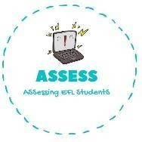
ENGLISH EXAM

Writing

Name: Surname: N^{ber}: Grade/Class:
Assessment: | Date:
 | Teacher’s signature: | Parent’s signature:

1. Find the words in the puzzle and write them.

H | S | I | G | F | E | S | A | O | J | L | G
H | A | V | E | D | I | N | N | E | R | K | B
U | K | V | F | S | W | A | T | E | G | V | C
C | Z | G | E | T | D | R | E | S | S | E | D
K | M | E | A | L | Z | T | V | F | R | H | J
Q | W | A | K | E | U | P | H | G | E | A | I
O | G | T | E | F | D | N | X | A | N | B | G
V | D | G | H | J | F | C | C | Z | V | J | H
S | A | W | Q | E | R | F | G | H | J | K | L

1. H _ _ _ _ D _ _ _ _ _
2. H _ _ _ _ L _ _ _ _
3. G _ _ D _ _ _ _ _ _
4. W U _

Assessing EFL Students

