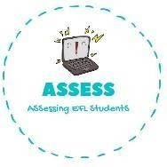
ENGLISH EXAM

Writing

Name: Surname: N^{ber}: Grade/Class:
Assessment: | Date:
 | Teacher’s signature: | Parent’s signature:

1. Match the times to the pictures and complete the words.

8 o’clock | Half past 12 | 21 o’clock

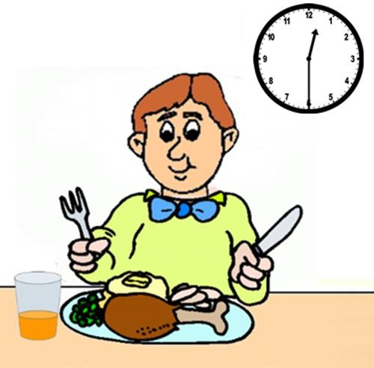

H _ _ _ L _ _ _ _ | H_ _ _ B _ _ _ _ _ _ _ _ | H _ _ _ D _ _ _ _ _

Assessing EFL Students

