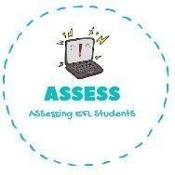
ENGLISH EXAM

Writing

Name: Surname: N^{ber}: Grade/Class:
Assessment: | Date:
 | Teacher’s signature: | Parent’s signature:

1. Answer the questions about this picture.

-Who are they? They are a _. The m ,
f ,
s and b .

-What are they doing? They are

-What is their pet? It is a

-How are they dressed? Example: The mother is wearing a white shirt and yellow jeans. The father is wearing a T-shirt and pants.
The son is wearing a and . The daughter is wearing a

-What do you do with your family? .

Assessing EFL Students

