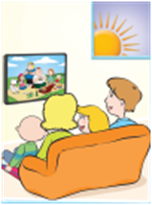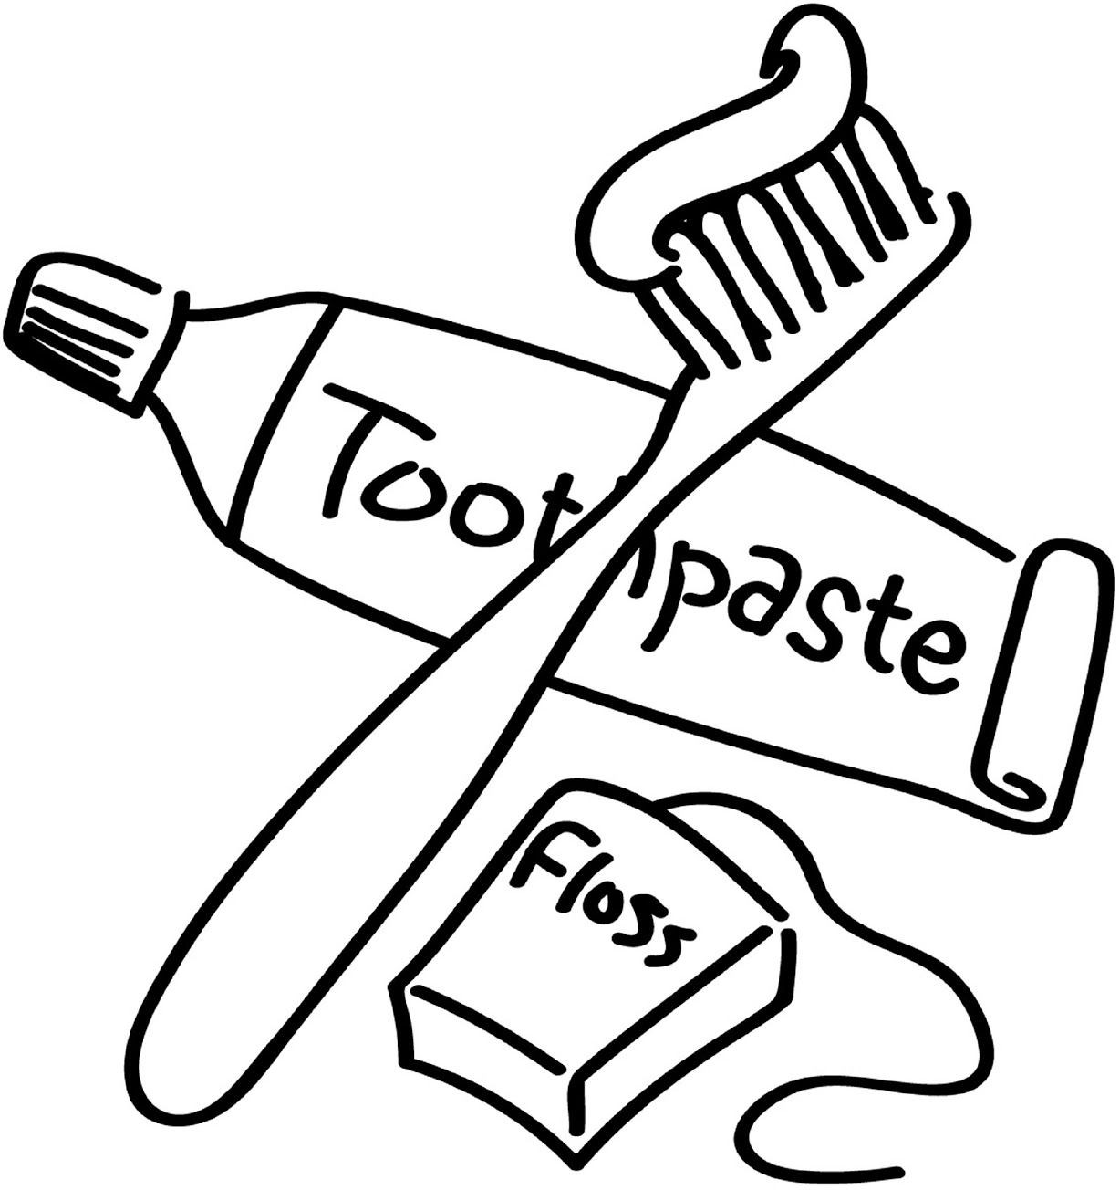

TOPIC: Routines | SUBTOPICS: Talking about Routines and telling time | LEVEL: A2
Name: Surname: N^{ber}: Grade/Class:

- Write the verbs under the pictures

brush my  teeth | watch tv | wash my  face | do homework | have breakfast | go to  school

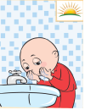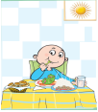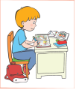

……………………. …………………… …………………….. ………………………
………………………. ………………….

- Fill in the blanks

have / read / go / watch

- I …………………… a book in the evening. 3. I to school at 8 o’clock.

- I …………………… tv in the afternoon. 4. I a shower at night.

- Fin the days of the week.

M | O | N | D | A | Y | A | L | Y | T
T | U | E | S | D | A | Y | C | A | N
Q | W | E | D | N | E | S | D | A | Y
T | H | U | R | S | D | A | Y | L | P
F | F | R | I | D | A | Y | Z | S | W
P | Q | S | A | T | U | R | D | A | Y
N | N | S | U | N | D | A | Y | D | H
1. ……………………………………..
2. ………………………………..……
3. ……………………………….………
4. ……………………………………….
5. ……………………………………….
6. ………………………………..………
7. …………………………………….….

- Match the times

1) 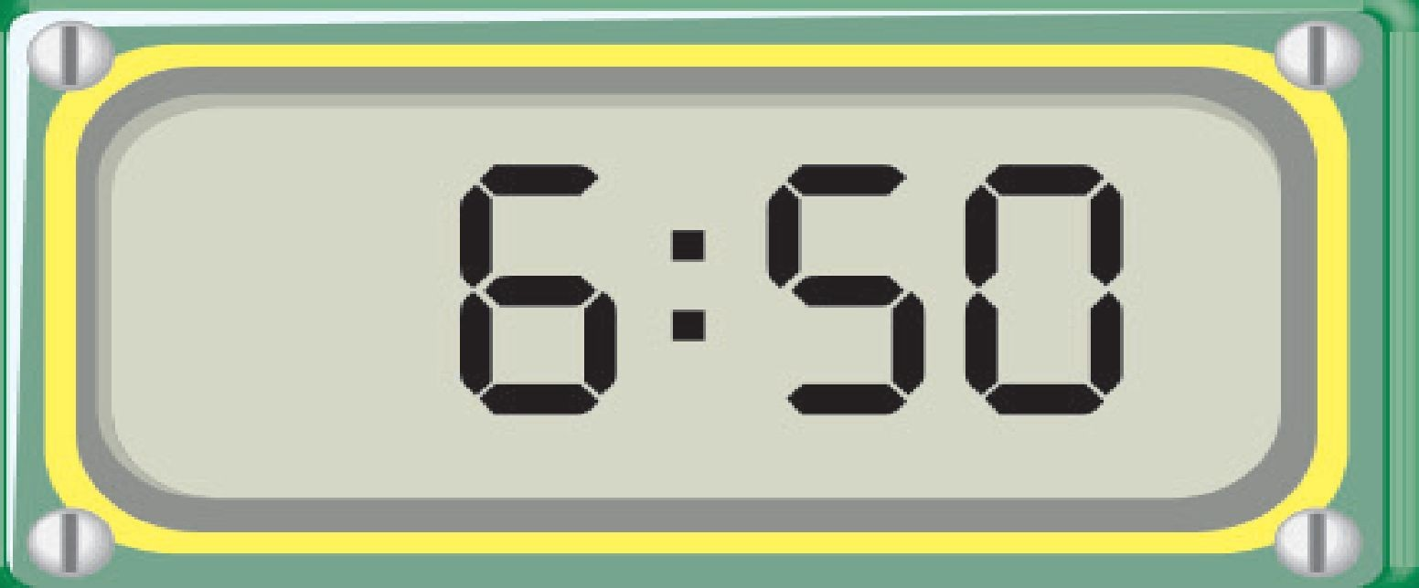 2) 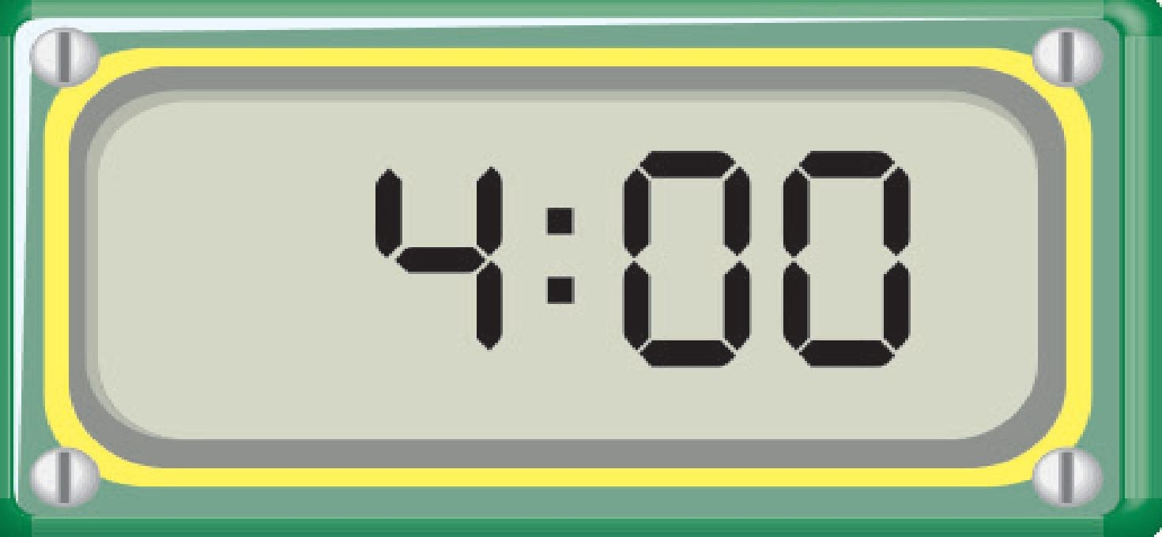 3) 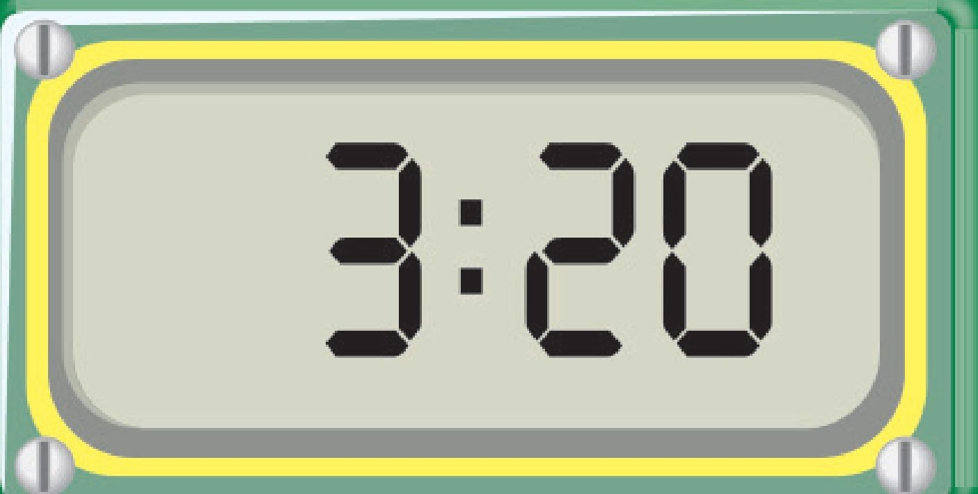 4) 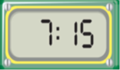

  - It is four o’clock(………..) c)It is six,fifty(………)
  - It is seven,fifteen(……….) d)It is three,twenty(………)

