Name: ____________________________ Surname: ____________________________N^{ber}: ____ Grade/Class: _____
Assessment: _____________________________ | Date: ___________________________________________________
 | Teacher’s signature:  ___________________________ | Parent’s signature:  ___________________________

- Listen and write the letters which relates to the right hand side examples.
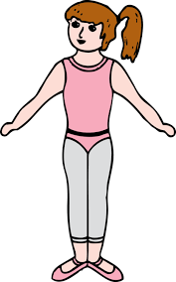

B

B
A

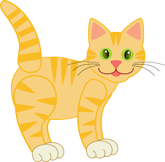
C

D

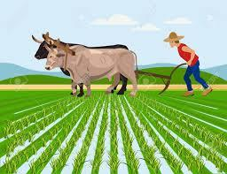
- Listen and match.

Martin

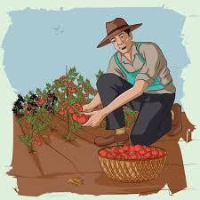

Joseph

TRANSCRIPT

EXERCISE 1

- Fish lives in water.
- Human beings need food to survive.
- Plant needs sunlight to grow.
- Cats drink milk when hungry.

EXERCISE 2

- Martin plows the field.
- Joseph is harvesting vegetables.

