Name: ____________________________ Surname: ____________________________N^{ber}: ____ Grade/Class: _____
Assessment: _____________________________  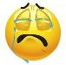  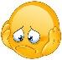 | Date: ___________________________________________________
 | Teacher’s signature:  ___________________________ | Parent’s signature:  ___________________________

- Listen and colour.

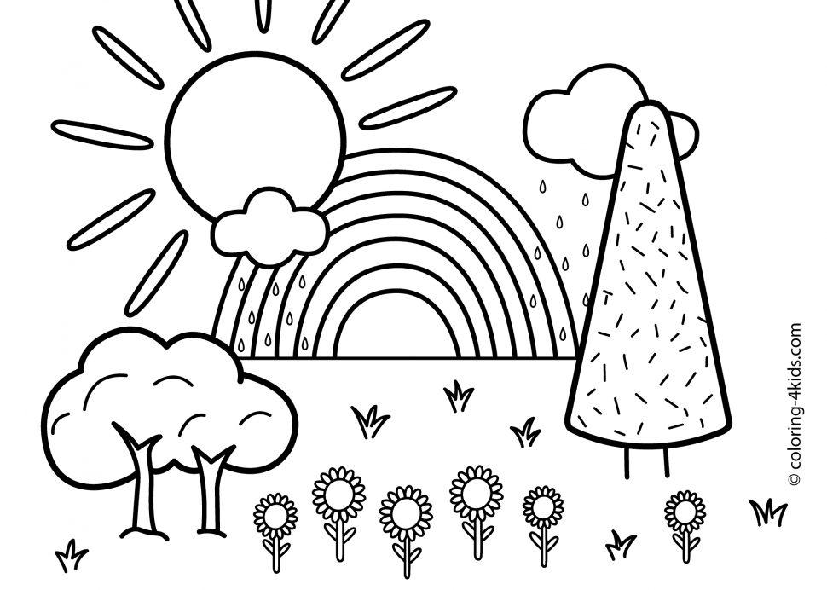

- Listen and link.
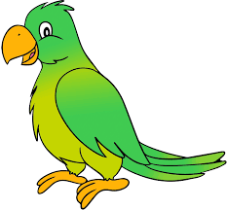
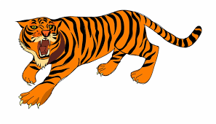
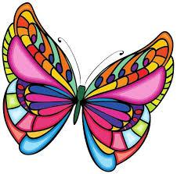

. . . .

. . . .
Insect

Animal

Human

Bird

TRANSCRIPT

EXERCISE 1

One
Teacher: Look at the Sun. Can you find it?
Rhea: Yes, I can.
Teacher: Colour the Sun yellow.
Rhea– OK.

Two
Teacher: Can you see the cloud?
Rhea: Can I colour it?
Teacher: Yes. Colour the cloud white!
Rhea: Sure.

Three
Teacher: Find the Rainbow and colour it.
Rhea: What colour?
Teacher: There are seven colours in the Rainbow – Violet, Indigo, Blue, Green, Yellow, Orange and Red.
Rhea: Wow! I love it!

Four
Teacher: Now color the trees and grass.
Rhea:: Yes.
Teacher: Colour the trees and grass green. Below you can find tree trunk, colour them brown.
Rhea: Of course.

Five
Rhea: Can you see the sunflowers?
Teacher: Now, colour the sunflower yellow and its leaves green.
Rhea: I love this!

Six
Rhea: There’s mud for the trees, sunflowers and grass to grow.
Teacher: Now, colour the mud brown.
Rhea: Ok.

Seven
Teacher: The sky is left!
Rhea: Yes.
Teacher: Colour the sky blue.
Rhea: Sure.

EXERCISE 2

- AParrot is a bird.
- A Butterfly is an insect.
- David is a Human.
- A Tiger is an animal.

