Name: ____________________________ Surname: ____________________________N^{ber}: ____ Grade/Class: _____
Assessment: _____________________________ | Date: ___________________________________________________
 | Teacher’s signature:  ___________________________ | Parent’s signature:  ___________________________

- Listen and number.
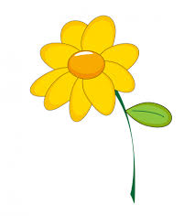
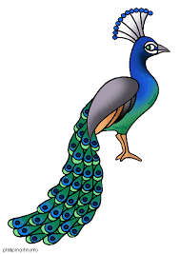

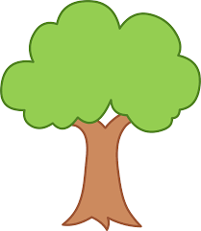
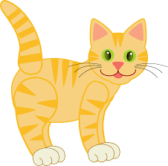

- Listen, link and colour.
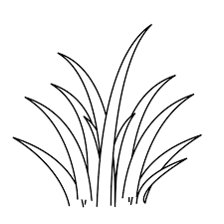
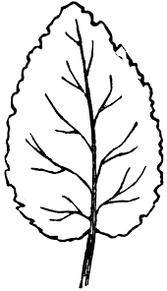
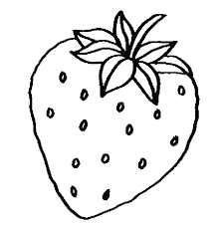

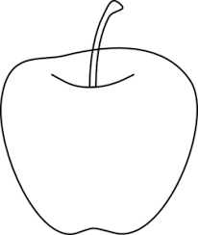

TRANSCRIPT

EXERCISE 1

- Plant
- Sun
- Rain
- Flower
- Tree
- Cat
- Mountain
- Peacock

EXERCISE 2

What’s green in nature? Come, let’s link and color.

- Leaves
- Watermelon
- Apple
- Grass

