Name: ____________________________ Surname: ____________________________N^{ber}: ____ Grade/Class: _____
Assessment: _____________________________ | Date: ___________________________________________________
 | Teacher’s signature:  ___________________________ | Parent’s signature:  ___________________________

- Listen and circle.
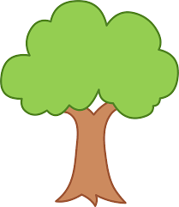

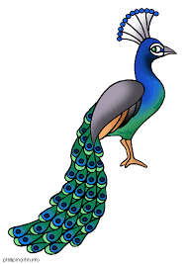

- Listen and link.
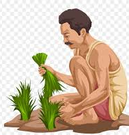

Jessie
Kavi
Victoria

. . .

. . .

TRANSCRIPT

EXERCISE 1

- Rain
- Peacock
- Sun
- Flower
- Mountain
- Tree

EXERCISE 2

- Jessie waters the tree.
- Victoria climbs a hill.
- Kavi is a Farmer. Rain helps his crops to grow.

