Name: ____________________________ Surname: ____________________________ N^{ber}: ____ Grade/Class: _____
Assessment: _____________________________ | Date: ___________________________________________________
 | Teacher’s signature:  ___________________________ | Parent’s signature:  ___________________________

Read the text.
Hi, I’m Lara. I like dolphins. I don’t like sharks. I love pigeons. I dislike bears.

1) Put a 😊 or ☹.
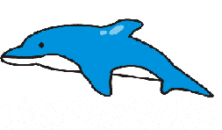 | 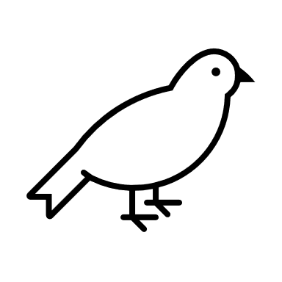 | 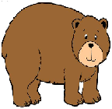 | 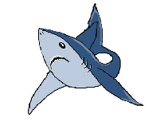

2) Match parts on the left with those on the right.
a) I like I) sharks.
b) I don’t like II) dolphins.
c) I love III) bears.
d) I dislike IV) pigeons.

Answer key. 1.
😊 | 😊 | ☹ | ☹

2.a-II; b-I; c-IV; d-III

