Name: ____________________________ Surname: ____________________________ N^{ber}: ____ Grade/Class: _____
Assessment: _____________________________ | Date: ___________________________________________________
 | Teacher’s signature:  ___________________________ | Parent’s signature:  ___________________________

- Read and link.
- There is a ladybird.
- There are two dolphins.
- There are six frogs.
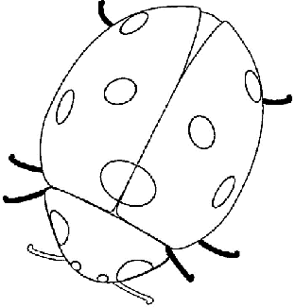
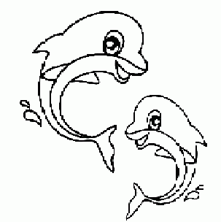
- There are two bees.
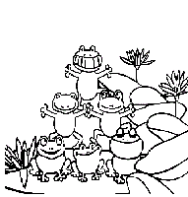
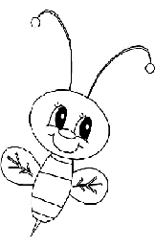

2) Read and colour the pictures in exercise 1.
a) The frogs are green.
b) The ladybird is red.
c) The dolphins are blue.
d) The bees are yellow.

Answer key.
- B; c; d; a.
- Colouring

