Name: ____________________________ Surname: ____________________________ N^{ber}: ____ Grade/Class: _____
Assessment: _____________________________  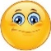  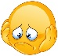  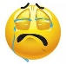 | Date: ___________________________________________________
 | Teacher’s signature:  ___________________________ | Parent’s signature:  ___________________________

Read and choose the best answer. Put a tick.

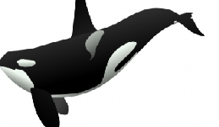
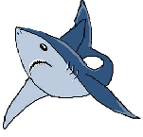
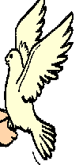
- This is a pigeon.
a) b) c)

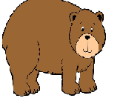
- That is a whale.
a) b) c)

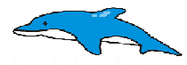
- This is a dolphin.
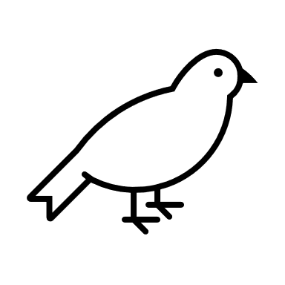
a) b) c)

- This is a forest.
a) 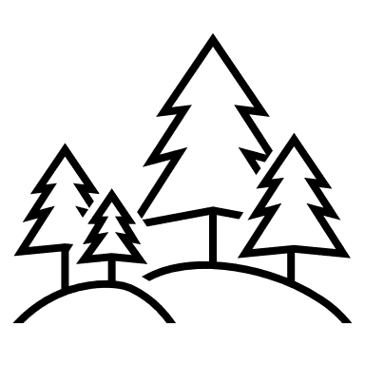 b) 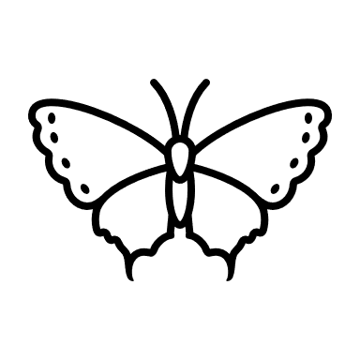 c) 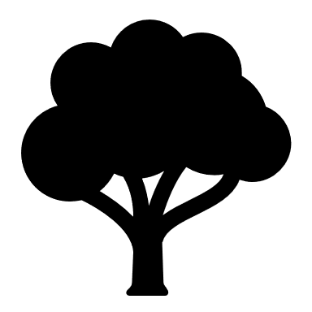

Answer key:
1.a; 2. b; 3. c; 4.a.

