Name: ____________________________ Surname: ____________________________ N^{ber}: ____ Grade/Class: _____
Assessment: _____________________________ | Date: ___________________________________________________
 | Teacher’s signature:  ___________________________ | Parent’s signature:  ___________________________

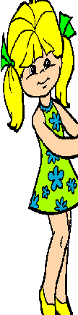
- Read and circle.
I’m Molly. I am at the zoo. This is a bear. It is brown/green. That is a dolphin. It is blue/red. And that is a frog. It’s blue/green.

- Complete the chart. Put a tick or cross.
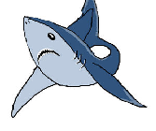 | 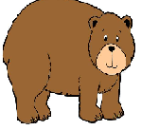 | 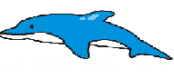

3) Read the text again and circle Yes/No.
a) That is a shark. Yes No
b) The dolphin is blue. Yes No
c) The frog is green. Yes No

Answer key:
- brown, blue, green. 2.
X | yes | yes

3. no, yes, yes.

