Name: ____________________________ Surname: ____________________________ N^{ber}: ____ Grade/Class: _____
Assessment: _____________________________ | Date: ___________________________________________________
 | Teacher’s signature:  ___________________________ | Parent’s signature:  ___________________________

- Ask your partner.
Do you like frogs?
Do you like ladybirds?
Do you like bees?
Do you like bears?
Do you like sharks?
Do you like dolphins?
 | 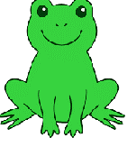 | 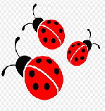 | 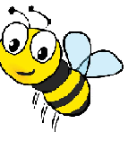 | 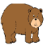
Your partner’s answers

- Answer your partner’s questions.

Answer key:
Your partner’s answers | Yes/No | Yes/No | Yes/No | Yes/No | Yes/No | Yes/No

