Name: ____________________________ Surname: ____________________________ N^{ber}: ____ Grade/Class: _____
Assessment: _____________________________ | Date: ___________________________________________________
 | Teacher’s signature:  ___________________________ | Parent’s signature:  ___________________________

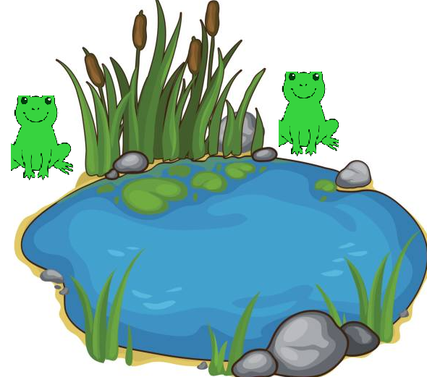
- Teacher’s questions.

Is there a ladybird?
Are there four frogs?
Is the frog red?
Is the frog green?
Do you like frogs?

Answer key:
No.
No, there are two frogs.
No.
Yes.
Yes/No.

