Name: ____________________________ Surname: ____________________________ N^{ber}: ____ Grade/Class: _____
Assessment: _____________________________ | Date: ___________________________________________________
 | Teacher’s signature:  ___________________________ | Parent’s signature:  ___________________________

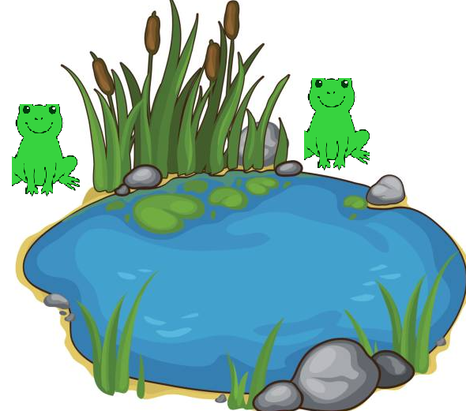
- Find differences.

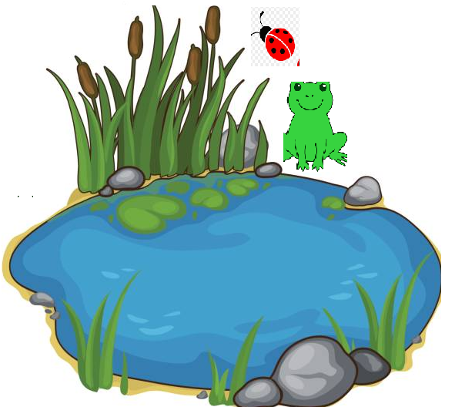

Answer key:
Picture B.
There is one frog.
There isn’t a bee.
There is one ladybird.

